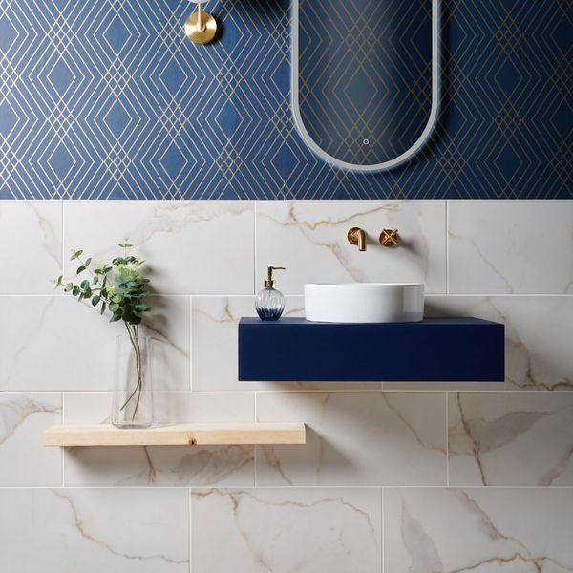

Ruscello Gold Gloss Marble Effect Tiles: <https://www.wallsandfloors.co.uk/ruscello-gold-gloss-60x30-marble-effect-tiles>

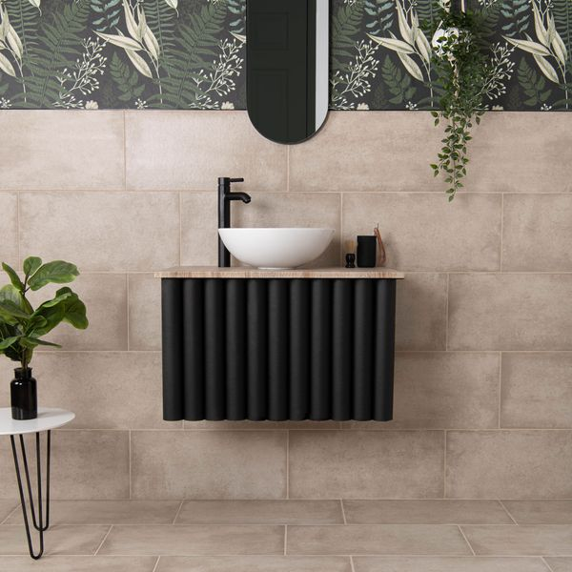

Samphire Matt Beige Tiles: <https://www.wallsandfloors.co.uk/samphire-matt-beige-tiles>

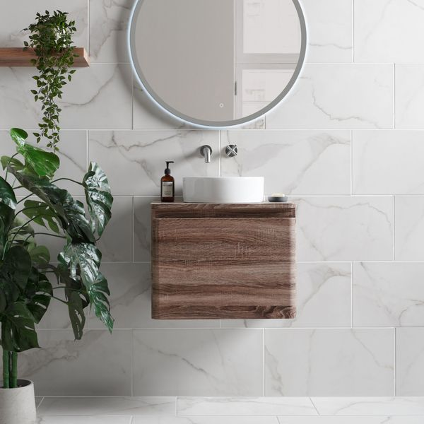

Ruscello White Gloss Tiles: <https://www.wallsandfloors.co.uk/ruscello-gloss-carrara-marble-effect-tiles-1>

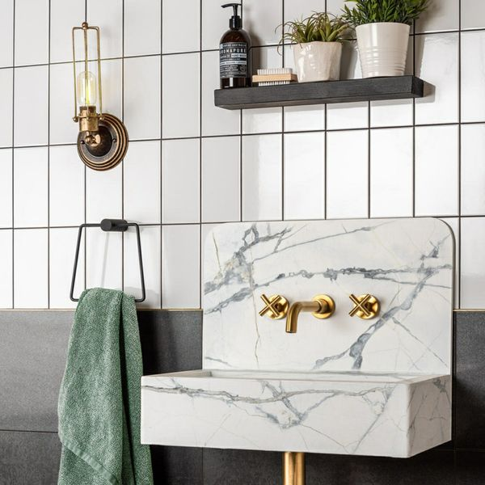

Flat Whitechapel White Gloss Tiles: <https://www.wallsandfloors.co.uk/flat-whitechapel-white-gloss-200x100-tiles>

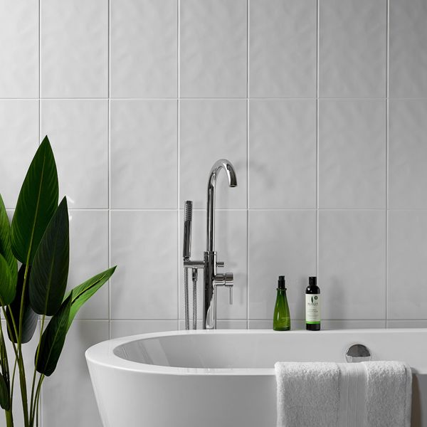

Innocence White Bumpy Gloss Tiles: <https://www.wallsandfloors.co.uk/innocence-whites-white-bumpy-gloss-400x250-tile>

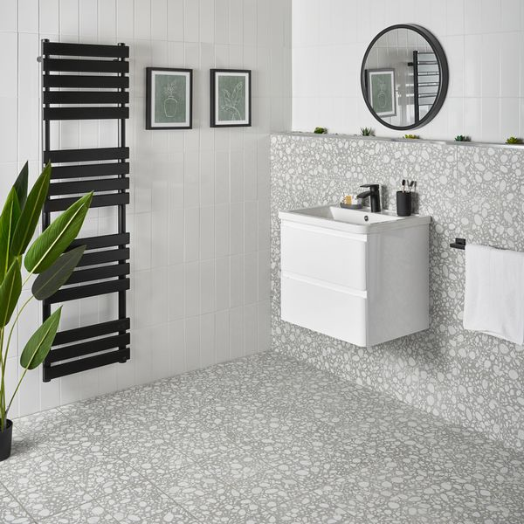

Linear White Gloss Brick Tiles: https://www.wallsandfloors.co.uk/linear-tiles-white-gloss-linear-tiles